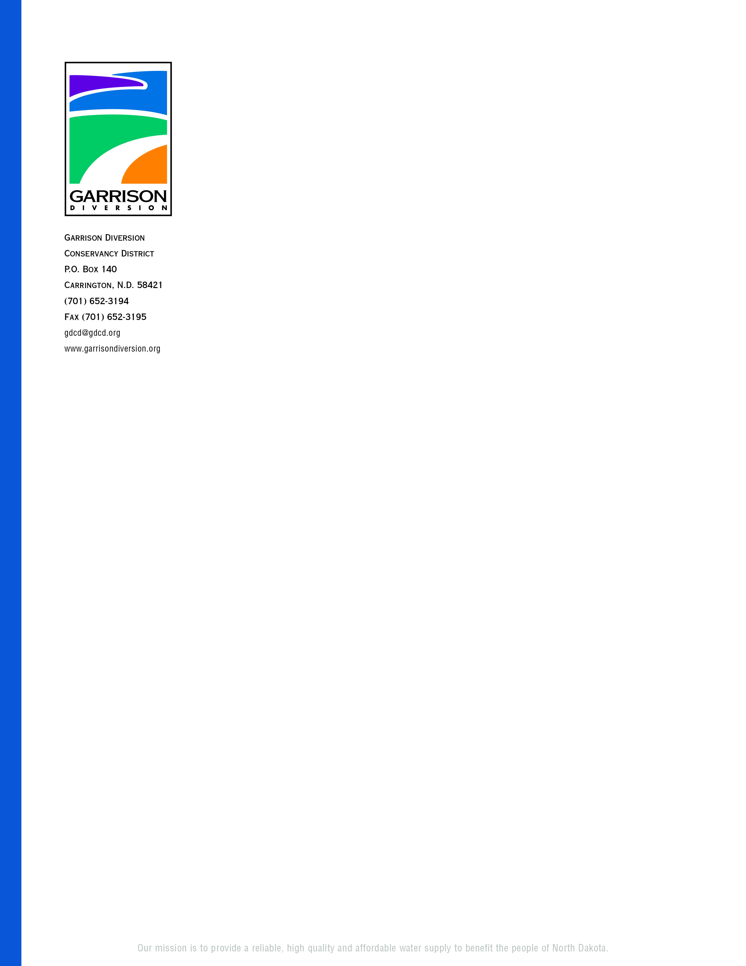

**GARRISON DIVERSION CONSERVANCY DISTRICT**

**RED RIVER VALLEY COMMITTEE**

**NOTICE OF MEETING**

**DATE: Tuesday, December 12, 2023**

**TIME:** **Following adjournment of LAWA TAC meeting –**

**approximately 1:45 p.m.**

**PLACE: Advanced Engineering & Environmental Services**

**4050 Garden View Dr., Suite 200**

**Grand Forks, ND**

Garrison Diversion Conservancy District’s Red River Valley Committee will meet as indicated above. Committee members are also encouraged to attend/participate in the LAWA Technical Advisory Committee meeting beginning at 9:30 a.m.

The purpose of the meeting(s) is to provide a Red River Valley Water Supply Project (RRVWSP) 2023 construction review, 2024 construction outlook, demand allocation report, pipeline hydraulic analysis, program cost update and to review and consider various task orders.

If you are unable to attend the meeting in person, you may join the meeting via Teams using the information provided below.

**Join on your computer, mobile app or room device**

[Click here to join the meeting](https://teams.microsoft.com/l/meetup-join/19%3ameeting_ZGYxMmM5ZDktNjI1Mi00ZDZlLWEzYWQtYTQyYTA1YjczODAx%40thread.v2/0?context=%7b%22Tid%22%3a%22b32addb5-f43d-4c2a-8383-dd63422a2655%22%2c%22Oid%22%3a%22c773b1d8-fa5a-461e-9b04-754d04e2431d%22%7d)

Meeting ID: 295 118 799 977   
Passcode: BtAzv2

[Download Teams](https://www.microsoft.com/en-us/microsoft-teams/download-app) | [Join on the web](https://www.microsoft.com/microsoft-teams/join-a-meeting)

**Join with a video conferencing device**

[187186316@teams.bjn.vc](mailto:187186316@teams.bjn.vc)

Video Conference ID: 113 883 382 7

[Alternate VTC instructions](https://support.bluejeans.com/knowledge/vtc-dial-in-options-for-teams)

**Or call in (audio only)**

[+1 701-566-0964](tel:+17015660964,,497220388# )    United States, Fargo

Phone Conference ID: 497 220 388#

DD/las